S. C. I

World

Newsletter of the Joseph Groh Foundation
Spring - Summer 2017

News Bytes
Dallas Golf Tournament is the Best Yet!

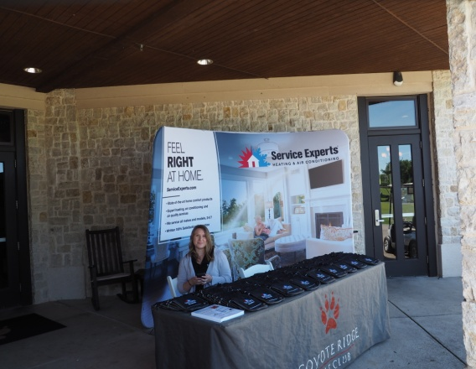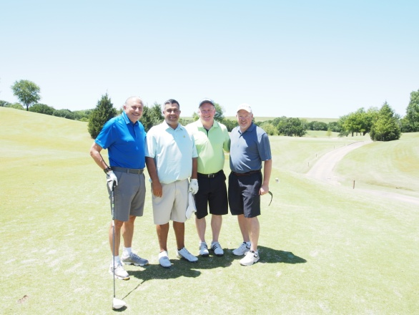
Title sponsor Service Experts Scott Boxer (on left) of Service Experts
welcome table with his golf group

From tee to green golfers enjoyed good weather and great camaraderie!

On Monday, May 1 early morning skies foretold of a beautiful day ahead… and indeed it was! The weather was near-perfect for the 126 golfers who signed up to play in the 2017 Service Experts tournament for the Joseph Groh foundation. A record number of sponsors (see banner below) made this the best tournament ever for the foundation, with a total of $60,000 (gross) raised! During dinner following the tournament, the parents of a recent grant recipient, Jeremy Ray, spoke to the golfers about their son’s story. They read a letter written by their son which chronicled his accident, some of the difficulties he faced following that and how the foundation had helped make their life easier. The foundation paid for a ramp built in back of their house, the replacement of carpet in the house with hard surface flooring and a bath remodel for accessibility. Scott Murray once again was the host for post-golf activities. Scott spent over 3 decades with NBC as a multiple Emmy award-winning sports anchor, having been named sportscaster of the year 17 times by various news organizations. Golfers and guests also shopped at the silent auction where 44 separate offerings were available ranging from high-end restaurant/hotel packages to Texas Rangers and Dallas Cowboys tickets. The foundation thanks all the sponsors, golfers, donors and volunteers for making this a record-setting event!

St. Louis Contractor Holds Raffle for the Foundation

Budget Heating, Cooling & Plumbing of St. Peters, Missouri recently held their annual Family Fun Day Saturday for their employees. This is the 3rd annual such event, and the day was spent playing games, eating barbecue and enjoying each other’s company. As part of the event, Budget hosted a raffle with proceeds going to our foundation. This is the 2nd year they have raised money for our foundation through this event. Amy Davis, Vice President of Budget Heating, Cooling and Plumbing said, “it’s important to us to support those that give back to our trade.” Budget’s employees and families helped raise $446 for the foundation, but the donations for our foundation did not stop there. Budget made the decision to match the donation, allowing a grand total of $892 to be donated to the Joseph Groh foundation! The foundation sincerely thanks Amy and all of Budget’s employees for their generosity and support!

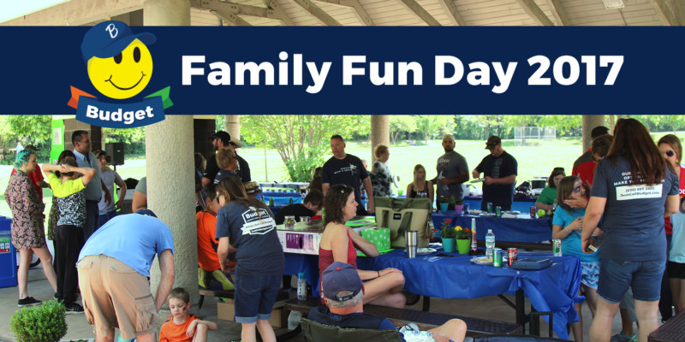

ADA Under Attack

On January 24, 2017 Representative Ted Poe (Republican, Texas) introduced HR 620, legislation entitled ADA Education and Reform Act of 2017. The bills stated purpose is to “amend the Americans with disabilities act of 1990 to promote compliance through education, to clarify the requirements for demand letters, to provide for a notice and cure period before the commencement of a private civil action, and for other purposes.” That seems innocuous enough, but let’s dig a little deeper.

HR 620 is part of a series known as ADA notification bills. Backed by the business lobby, these bills essentially seek to remove the incentives for voluntary compliance, while requiring a person with a disability to detail the exact ADA provisions that they allege are being violated. The 27-year-old ADA legislation obligated businesses to make themselves accessible under penalty of consequence. Under HR 620, there would be no consequence, and thus no incentive, to comply with ADA. Supporters of this legislation cite concerns about frivolous lawsuits and money damage awards arising from ADA. In reality, ADA attorneys and plaintiffs are typically seeking solutions to fix actual denials of access, because ADA does not allow for monetary damages. Furthermore, the notification aspect seeks to place the heaviest burden for ending discrimination on the very people the law is supposed to protect. Help us send a message that this is unacceptable!

What can you do? Simply go to contactingcongress.org and insert your ZIP Code to find a variety of methods for contacting your House representative. Suggest to them they should spend one week trying to fulfill their normal schedule while operating from a wheelchair. They may well have not ever read the actual legislation that created The Americans with Disabilities Act, but if they were to spend a week in a wheelchair they wouldn’t need to. They would simply drop their support for this ridiculous legislation!

Critical Update on Complex Rehabilitative Equipment

We have written about this before, but now time is critical for this important bill. First however, a brief review. What is complex rehabilitative equipment (CRT)? CRT refers to products and services, including medically necessary, individually configured manual and power wheelchair systems, adaptive seating systems, alternative positioning systems, and other mobility devices that require evaluation, fitting, design, adjustment and programming. In other words, wheelchairs like mine. If Congress does not pass HR 1361 and S 486 or take other action by July 1, Medicare will move forward with its plan to implement major payment cuts to critical CRT wheelchair components. These cuts would create real access problems for people with disabilities who rely on this specialized equipment. The foundation is asking you to reach out now to your legislators and urge them to support this legislation. Simply go to the link below and put in your ZIP Code. This will bring up a letter tailored toward your House representative. This will literally take less than 5 minutes, we appreciate your action on this critical legislation!

http://action.aahomecare.org/ctas/ask-your-representatives-to-join-congressional-sign-on-letter-t

Upgrade to Platinum

The Joseph Groh Foundation is committed to making sure we have the full confidence of our valued donors and supporters. Toward that end, our foundation works hard to make sure our actions are transparent for any and all to see. Some years ago our foundation registered with GuideStar, a 501©(3) organization that collects, organizes and presents information about IRS registered nonprofit organizations. Our foundation was recently designated as a platinum participant by GuideStar, the highest such designation conferred by this organization. Platinum participant charities are those committed to providing annual revenue and expense information, mission statements and objectives, business plans, impact summaries and other information related to their operations. We invite you to take a closer look at us via guidestar.org, and see how we have been able to provide approximately $350,000 in grants to 40 individuals since our inception in 2009.

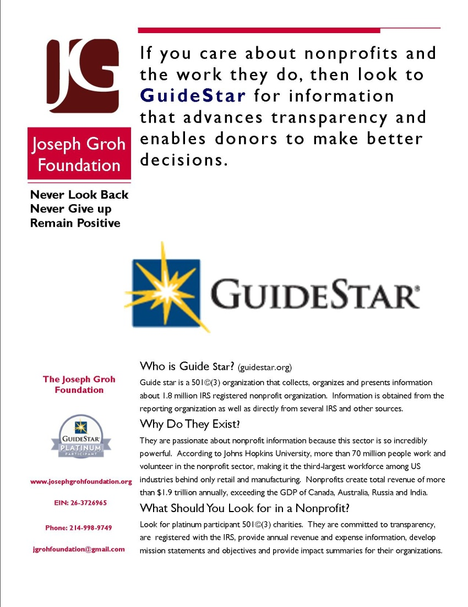

Secondary Conditions Affecting SCI Health

Back in the day, if I were to have seen a paralyzed individual in a wheelchair, the thing I would have focused on is their paralysis. For the individual in the wheelchair however, that may be about the last thing they are focused on. After all, for them paralysis is fait accompli. They are most likely focusing on secondary health issues, as failure to do so can often be fatal. I have listed some of these issues below along with a brief description of each.
- Autonomic Dysreflexia. This is a potentially life-threatening condition experienced when there is pain or discomfort below the level of injury. The autonomic nervous system controls body functions such as blood pressure, heart rate etc. through signals sent back and forth from the brain through the spinal cord nerves. These signals are blocked below the point of injury and blood pressure can rise to dangerous levels.
- Cardiovascular health. Mortality from cardiovascular disease now exceeds that caused by renal and pulmonary conditions among the spinal cord injured population.
- Respiratory illness. Respiratory infections, especially pneumonia, are one of the leading causes of death for people with spinal cord injuries, but account for less than 3% of deaths in the general population.
- UTIs. Urinary tract infections are the most common medical issue affecting individuals with spinal cord injury. These can lead to serious complications including kidney stones, bladder stones, renal failure and sepsis.
- Pressure Ulcers. These are injuries to the skin and underlying tissue that typically develop over bony areas. People with spinal cord injuries are at high risk for development of pressure ulcers which can lead to serious complications including sepsis very quickly.
- Other medical issues. In addition to those described above, other common medical problems facing individuals with spinal cord injury include those involving osteoporosis and resulting ongoing pain, bladder and bowel management, severe spasticity, sexual dysfunction & heterotopic ossification, (development a bone in abnormal areas)
- Non-medical issues. These include dealing with depression, finding employment, maintaining accessibility both in the home and in public, finding and keeping qualified caregivers and caring for caregivers, particularly if they are relatives or spouses.

Having knowledge and awareness of these issues goes a long way toward maintaining long-term health in spite of a spinal cord injury!

Cory Hahn – Someone You Should Know

Cory Hahn came by his passion honestly. His father, Dale Hahn, had played center field at Chico State. From the age of 4 or 5, Cory would watch the movie The Natural with regularity, and even wanted to be called Roy Hobbs. Cory’s father coached all of his youth league teams, and was an assistant on Cory’s travel teams. Cory became known as California’s Mr. Baseball in high school, leading Mater Dei high school to a section championship. He pitched 5 perfect innings in the title game, hit a homer and made a spectacular running catch to preserve the perfect game. He was recruited by 60 colleges, and was drafted by the San Diego Padres in the 26th round of 2010. He turned down their $300,000 bonus offer and accepted a scholarship with Arizona State University. He figured that 3 seasons with the Sun Devils would likely have boosted his draft status into an elite realm.

On February 20, 2011 in his 3rd game with the Sun Devils, Cory started in centerfield for the first time as a true freshman. Playing in the 2nd game of a doubleheader against New Mexico, he drew a first-inning walk, and with a runner on second base, the ASU coach call for a double steal. Hahn took off, and although he almost always slid feet first, this time he went headfirst. The throw was off-line and the New Mexico second baseman drifted to the left side of the bag to retrieve it. During the slide, Hahn slammed into the fielders right knee. Hahn heard a crack but didn’t think much about it. He saw the ball go into the outfield and he told himself to get up, but he couldn’t. At first he thought it was a stinger. There was no pain, his body went numb and he didn’t feel anything. The coaches ran out and Cory told them something was not right, and that he couldn’t move. They called Cory’s dad onto the field. At that point, the realization of his status began formulating in Cory’s mind. His dad was beginning to realize the same thing, and on the ride in the ambulance to the hospital, Cory could not look at his dad because the expression on his dad’s face spoke volumes. The diagnosis was devastating. Hahn was a quadriplegic, paralyzed from his mid chest to his toes.

Cory had become a rarity, a baseball player who suffered a spinal cord injury during a game. The news spread quickly throughout the baseball community. Los Angeles Dodgers outfielder Andre Ethier, who starred at ASU, was the first person outside of family to see Cory. Arizona Diamondbacks president Derek Hall and 2001 World Series hero Louise Gonzales arrived next. This was followed by teammates and friends, and on the final day before he was flown home, Cory’s father was stunned to see a familiar face get off the elevator. It was Josh Hamilton, American League MVP with the Texas Rangers. Josh spent about an hour and a half with Cory, talking about baseball and praying for his recovery.

One year after returning home to California, Cory told his family he wanted to return to Arizona State. Cory’s dad quit his job and rented a small one-bedroom apartment on campus to assist Cory every day. Every day, Cory’s dad spent 2 hours helping Cory get ready for school. He also took him to physical therapy and everywhere else he needed to go. It made family life difficult, but Cory’s mom visited every 2 weeks. Showing the same determination that made him successful in baseball, Cory took 20 hours of classes for 3 consecutive semesters to graduate from the WP Carey School of Business. He graduated with an economics degree, and eagerly looked forward to the next phase of his life. Graduating was a big thing Cory told himself. He not only proved that he could finish school, he proved to himself he was ready to go to work. He knew he couldn’t get on a ladder and paint or that he couldn’t be an electrician, but he knew he could help baseball. The Arizona Diamondbacks agreed and selected him in the 34th round of the 2013 draft – the round corresponding with his uniform number. They offered him his pick of jobs in broadcasting, sales or marketing. Hahn told them however that he was a baseball man and wanted to be in the scouting department. He was told that if he could do the job he would stay, but if not he was out.

Hahn didn’t disappoint. He helped organize daily scouting reports, going on back fields to watch games or scout amateur games. He studied video until his eyes are blurry, but there is one video he has never watched – that of his fateful slide. Cory didn’t need to see it, he had lived it. In Cory’s mind, there is no reason to look back, because doing so distracts you from what is really happening in life. “Don’t let someone tell you you can’t do something,” Cory says. “If you truly believe, you can. We’re all going to deal with adversity, whether big or small, but it’s not the adversity that defines who you are, it’s the way you handle it,” he said. Cory’s goal is to one day be in a position of power in order to help bring a World Series championship to the Arizona Diamondbacks. And one day, Cory wants to stand up again, get out of his wheelchair and walk. What is the first thing he would do? Hug his dad, squeezing him with all his might. “We’ve always been close,” Hahn says, but now now we are close in a different sense. He’s pretty awesome, isn’t he?” Like father, like son.

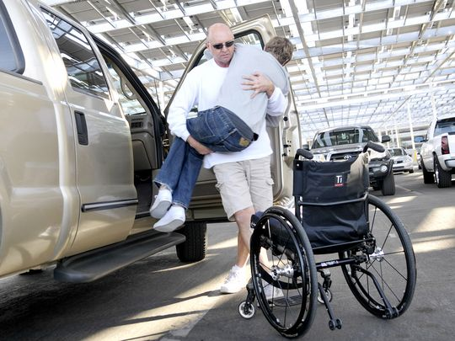
Cory’s father Dale, helping him into his wheelchair.

A Day in the Life

This feature is a sometimes humorous, sometimes offbeat, and sometimes irreverent look at life as seen through the eyes of a severely disabled person. Management takes no responsibility for these ramblings.

Random Acts of Kindness

Noteworthy acts of kindness are rare enough and random enough that when they occur, we are often taken by great surprise. I'm not talking about thoughtful gestures such as holding the door open for someone or bringing flowers home to your spouse for no other reason than that they are your spouse. I am talking about those true "holy cow" moments, when we are just knocked off our feet by the random kindness shown by others. Some examples.

A few years ago I had made a few calls to a former coworker who had been my go to IT person when we were both working together. I could always count on him to come up with a magic answer that would make my computer work like it should after some mysterious gremlin had crawled inside and created havoc. Not wanting to get on the "IT dunce list", I prided myself in only getting him involved with the problems which also caused him some consternation. I just loved to see his brow furrow and hear him softly say hmmmmm as he contemplated what I had done to the machine lately. But I digress.

A few years ago, I was beginning to experience multiple gremlins in my machine which, by most definitions, was old enough to rate dinosaur status. Once again I sought the advice of my former coworker, and after a few calls he was gracious enough to let me know he would be stopping by one evening after work along with another former coworker to look at it. I’m sure it didn’t hurt that I promised to have some cold Heffeweisen in the fridge! When these coworkers arrived on the appointed day, they both proceeded to look at my computer with furrowed brow. Suddenly, he stood up and looked at me with an expression on his face that I couldn't quite read. "You know Joe", he said, "I think I have the answer for you." "Really," I asked, “ what's that?" Reaching down, he straightened up with a smile on his face and said "this." My jaw dropped as he handed me a brand-new laptop. "It's from both of us," he said.

I once described another such incident on my Facebook page. My wife and I were having dinner at a local Cracker Barrel. I only noticed the older gentleman across the room because I saw the waitress refill his coffee, and it served to remind me of how cold it was in the restaurant. A few moments later this gentleman finished his dinner and he and his wife got up to head for the cashier. As he passed by our table, he reached down without pausing and picked up our check. My wife and I instantaneously protested that this wasn't necessary, but he would not take no for an answer. We learned only that his name was Bill, and my wife gave him a hug after which he proceeded on to the cashier. We had never seen him before and have not seen him since. Since that occurrence, the same thing happened a second time at Cracker Barrel, which is quickly becoming our favorite restaurant!

One other example happened even more recently. I was the president of our local homeowners Association and had called a meeting of the board to discuss matters needing attention. We always hold board meetings at our house because I know it is accessible. As one of the board members entered our home, he noticed that the door handle was loose. My wife mentioned it was a project awaiting one of our sons visits, but our neighbor quickly said "No big deal, can you just give me a screwdriver? A small one?" Sue did, and in a matter of minutes the door was fixed. We proceeded on with our meeting, and on the way out Sue decided to get bold. "Would you mind just looking at the toilet in our guest bathroom, "she asked our neighbor as he was leaving? "It seems to be running a lot." "Sure, no problem, " was his reply. After a few moments he emerged with the news that we really just needed to replace all the parts inside, and that he would get a kit and fix it first thing in the morning. Once again, we were more than mildly surprised. As will happen with guys, the conversation then meandered into the category of beer,and we found out that his favorite was a good lager. That evening we made sure to pick up a good brand at Market Street. The next day promptly at 9 AM he stopped by the house, and within 30 minutes all the components had been replaced. We gave him the six pack, and once again I marveled at yet another act of kindness. Since that time, we have had 2 other occasions to purchase his favorite lager!

At one point in my life, I would have refused these acts of kindness, insisting they were totally unnecessary. I might even have perceived them to be a statement of my own inadequacies. Now however when these things happen, I am prone to simply say "Thank You. From the bottom of my heart."

