S. C. I

World

Newsletter of the Joseph Groh Foundation
Fall 2016

News Bytes
2016 Chicago & Minneapolis Golf Tournament Are a Hit

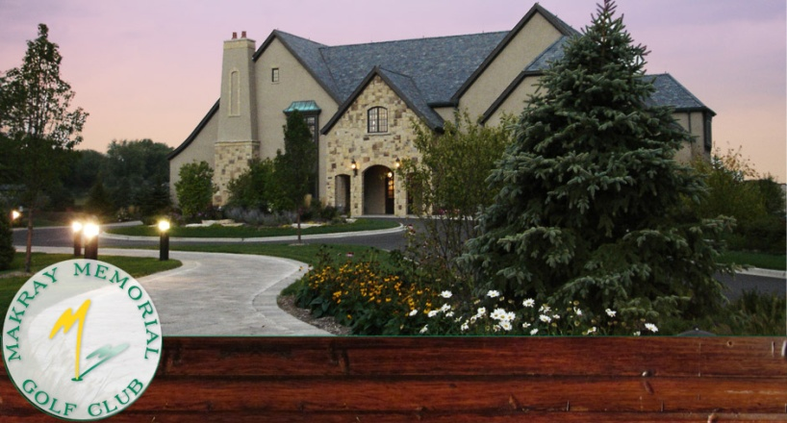

The 2016 Joseph Groh foundation golf tournament was held on Monday, August 29, 2016 at Makray Memorial Golf Club in Barrington, Illinois. The day started off under sunny blue skies, and 68 golfers came to participate in our 3rd annual Chicagoland event. Someone must have irritated the golf gods however, because after 8 holes the skies opened up and the rain forced golfers to finish the day at the bar in the clubhouse! Thank you to all our sponsors, donors and volunteers for making it a most successful tournament. A few pictures are shown below, a more full array can be seen on the websites Chicago Golf Page.

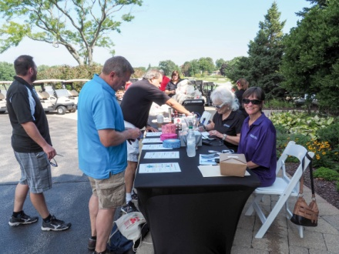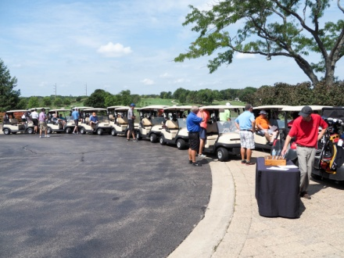
The day starts off looking perfect Carts are ready to go under blue skies

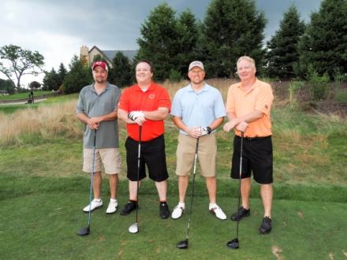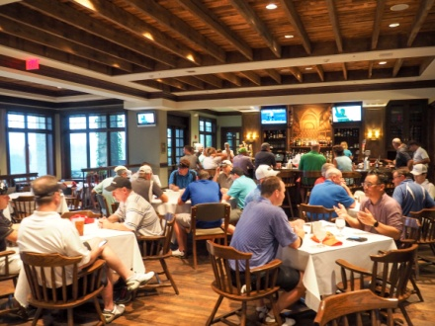
The sky started taking a turn for the worse The 19th hole is always sunny!

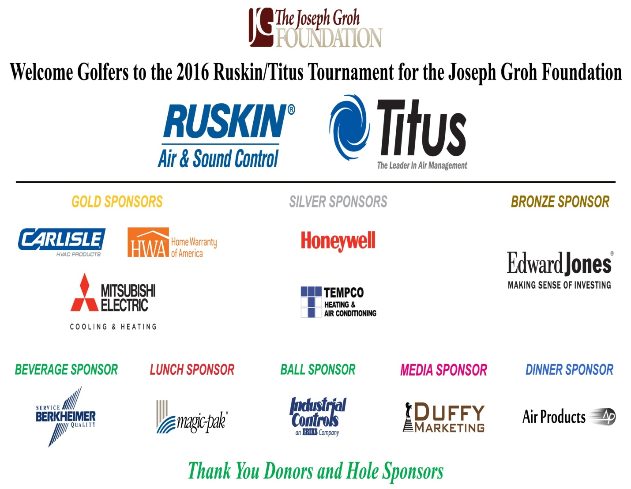
Thanks to all the sponsors, golfers, and donors who made this day possible!
The Links at North Fork in Ramsey, Minnesota

The 2016 Minneapolis golf tournament for the Joseph Groh foundation was held on Monday, September 12 At the Links at North Fork in Ramsey, Minnesota. The weather cooperated for the 60 golfers who turned out at our inaugural event. This represents the 3rd tournament in 3 different cities during 2016 for the Joseph Groh foundation. The featured recipient was Kevin Hakeneis of Fulda, Minnesota. The Joseph Groh foundation helped his family purchase a handicapped van as well as complete a deck and ramp on the exterior of the family home. Thank you to all our sponsors, donors and volunteers for making this a successful inaugural event! A few pictures are shown below, a more full array can be found on the websites Minneapolis golf page.

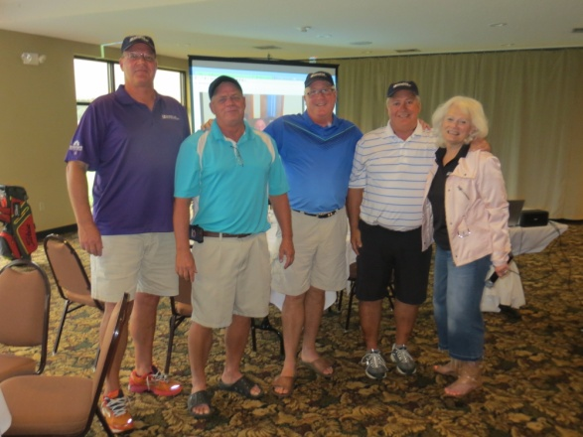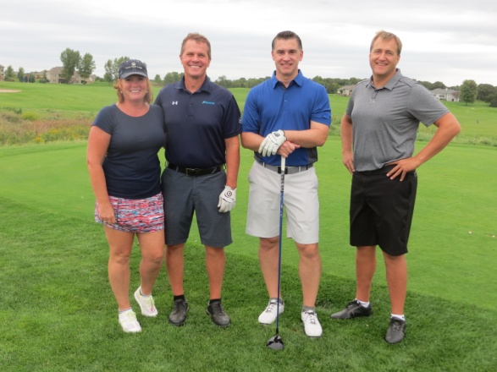
These golfers completed the “Hat Trick” Title Sponsor, Kirk Thorne with Daikin (2nd from l)
golfing in all 3 foundation tournament this year.
L to R Jack Poehls, Steve Klich, John Rohan,
Gary Doles, Vicki Laplant

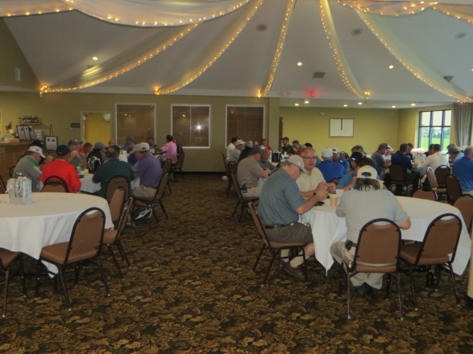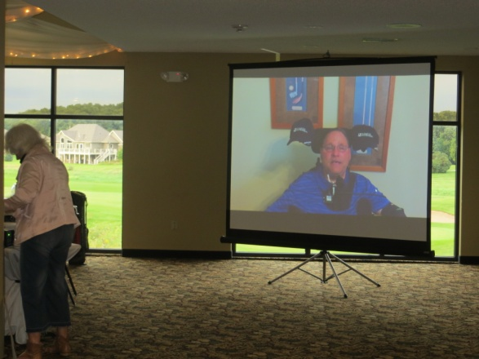
The 19th Hole Never Disappoints! Joe Groh Makes an Appearance Via Video

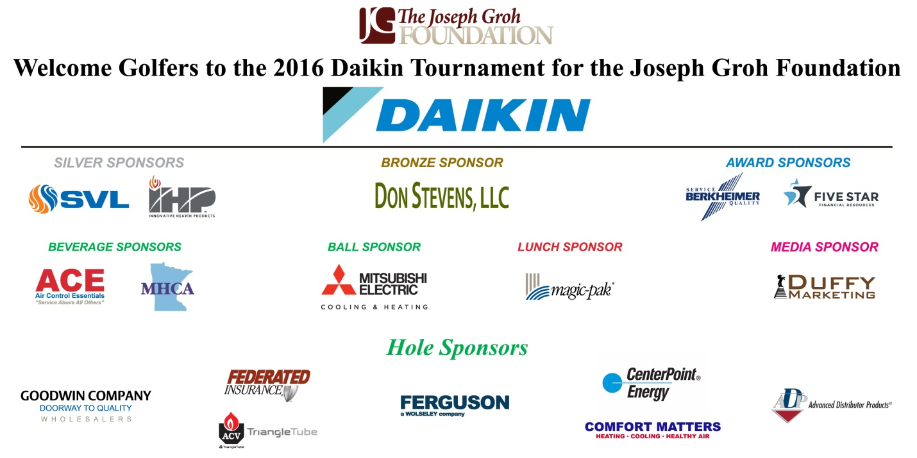

2017 Golf Tournaments

The foundation is announcing the following dates and locations for golf tournaments in 2017.

Dallas: Monday, May 1, 2017 Location: Coyote Ridge
Carrollton, Texas

Chicago: Monday, August 28, 2017 Location: Itasca Country Club
Itasca, Illinois

Minneapolis: Monday, September 11, 2017 Location: Links at North Fork
Ramsey, Minnesota

Thus far in 2016, the foundation has provided 7 grants and is in the midst of funding 3 more. These golf tournament’s have been the driver (pardon the pun) behind this, and we thank everyone who has helped make them possible!

Addison Rotary

Software leader ServiceTitan held a promotion in April and May, 2016 to benefit the Joseph Groh foundation, raising $10,000 in the process! In actuality, there were two promotions which ran during this timeframe for the foundation. The first featured a $1000 donation for every Service Roundtable member who signed up for a software package, and the second pledged a $1000 donation for every referral that led to the purchase of a software package. In both cases, ServiceTitan also offered the purchasing contractor a $1000 savings off their Customer Success Package!

ABLE Accounts

Did you know there are tax advantaged savings accounts for individuals with disabilities and their families? It was all part of the Achieving a Better Life Experience Act (ABLE) which was passed in 2014. The beneficiary of the account is the account owner, and income earned by the account will not be taxed. Contributions made to the account by anyone are made using post tax dollars and will not be tax-deductible, although some states may allow for a state income tax deduction. Millions of individuals with disabilities and their families depend on a wide variety of public benefits for income, (SSI) healthcare, (Medicaid) and food and housing assistance. (SNAP) Eligibility for these benefits require meeting a means test that defines the individual as poor. For the 1st time in public policy, the ABLE ACT recognizes the extra and significant costs of living with a disability. Dollars in these accounts will not affect the individual’s eligibility for public benefits and can be used for a wide variety of expenses not covered by insurance, Medicaid or Medicare. Specifically, a qualified disability expense is one related to the designated beneficiary as a result of living a life with disabilities. They are intended to pay for expenses which help improve health, independence, and/or the quality of life. To be eligible, an individual must have incurred their disability before turning 26 years of age. The total annual contribution by all participating individuals for single tax year is $14,000. Check with your state for specifics, and you can find more information by following the link below.

http://ablenrc.org/about/becoming-able-ready

Amazon Echo

No doubt you have heard about the latest voice controlled technology from Amazon called Echo. Echo is a hands-free speaker that you control with your voice to play music, provide information and control your environment. It is Bluetooth enabled so you can stream popular music services like iTunes from your phone or tablet. In addition, it can play music based on your favorite artist or song, as well as provide music from a specific genre or mood. Disabled individuals however are likely more interested in the far-field voice recognition capabilities of Eco. The more you use it the more it adapts to your speech patterns, vocabulary and personal preferences. Echo can be used to switch on lights, fans, switches, thermostats and more from WebbMo, Phillips Hue, SmartThings, Insteon, Nest, ecobee and Wink. Some products work directly with echo “Alexa” while other smart home ecosystems require a compatible hub. Professionals in the field say that Amazon Echo cannot rival the prowess of voice based assistive technology yet, but they acknowledge that voice recognition is a coming phenomena – and not just for the disabled!

Foundation to Launch New Initiative

The Joseph Groh foundation was launched to accomplish 3 objectives.
1. Serve as a clearinghouse of information for those living with life altering disabilities
2. Provide financial assistance to those with a connection to the construction trades who are also living with a life altering disability
3. Encourage companies to offer and employees to sign up for short and long-term disability insurance

Up to now, the foundation has only been actively in pursuit of the first 2 objectives, but that will change in 2017! Consider the following:
A major disability is something that happens to someone else… Until it doesn’t! The sad fact is most Americans are better prepared to die than they are to deal with disabilities. Just over 1 in 4 of today’s 20-year-olds will become disabled before they retire. In fact, over 37,000,000 Americans or about 12% of the total population are classified as disabled, and 8,800,000 wage earners are receiving Social Security disability insurance. (2.5 million of these are in their twenties, thirties and forties) Stay tuned for more details about this initiative throughout 2017!

Amberly Snyder – A Person You Should Know

Amberly Snyder
Amberly Snyders passion for horses began when she was 3 years old and taking weekly riding lessons. She decided to leave horseback riding however for other sports hobbies due to frustrations about her legs being too short to pass the saddle pad so she could kick the horse to go faster. As she grew she decided to go back to riding. Even though her home state of California did not have rodeo competitions, she would take her pony out and set up cones in order to do her own barrel patterns. At the age of 7, her family moved to Utah where her dad, a professional baseball player, got her a barrel horse. Rodeo became a huge passion from then on and has stuck with her ever sense. All this was challenged however on January 10, 2010 when Amberly was in a car accident.

Heading to Denver for his talkshow, Amberly was driving through Wyoming when she looked down to check her map. As she looked up, she realized she had faded over a lane and was headed toward a metal beam on the side of the road. She grabbed the wheel and the tail end of the truck started sliding out. As she tried to correct the slide, the truck went off the road completely sideways. “I remember thinking that this was not going to end well as I felt the truck pick up off the ground and begin to roll,” she said. When the rolling ended, Amberly opened her eyes and found herself sitting in a snow bank on the side of the freeway. She had hit a fence post across her stomach, which broke her back. While able to move her fingers, she did not have any feeling in her legs. She underwent 5 hours of surgery which left her with hardware in her back. Amberly rehabbed at Utah Valley Hospital in Provo, where doctors told her she would not gain feeling below her waist or regain mobility in her legs.

Kimberly was determined to get back on her horse following the accident, but when she did for the first time the realization is not what she expected. Amberly came face to face with the realization that life was not going to be the same, and that she would have to deal with this moving forward. She decided to take a break from riding and went to college to fill the void that riding left in her heart. About one year later she was contacted by a newspaper who wanted to take photos of her on her horse. By this time Amberly’s mindset was different, as she was more accustomed to the changes in her life. When she got on her horse, she experienced an unforgettable feeling, and that was she was not going to give up riding. She convinced her therapists to let her bring a saddle into therapy where she learned to gain her balance. She used a seat belt around her waist, Velcro for her legs and stirrups and a nylon strap to keep her from moving around during barrel turns. Making small goals and accomplishing them, she would then set new goals that were more audacious. Within a few months, she convinced her doctors and parents to allow her to ride again.

Since then she has won over 60 buckles and 7 saddle competitions, and in 2009 was in the finals in the World All-Around Cowgirl of the Little Britches Association. She continues to ride and competes in the Pro rodeo circuit. She plans to graduate with her Bachelors in Agricultural Education And Masters in School Counseling. Amberly says that when you get back to what you love, you have the opportunity to inspire others because of the situation you are in. Amberly advises that your attitude can either be your biggest obstacle or your greatest strength – you just have to decide which one it will be.

Story courtesy of mobile women.org
http://www.mobilewomen.org/2015/11/amberley-snyder-women-riding-her-way.html

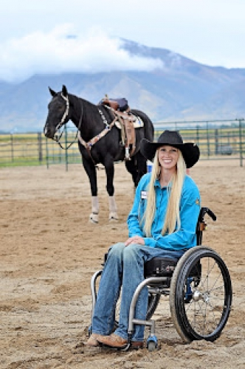
Amberly Snyder and her horse, Power

A Day in the Life

This feature is a sometimes humorous, sometimes offbeat, and sometimes irreverent look at life as seen through the eyes of a severely disabled person. Management takes no responsibility for these ramblings.

Grounded – And Other Technology Issues
The Winter-Spring 2015 foundation newsletter featured an article about Barbara Turnbull as the person you should know. As a refresher for those of you without an encyclopedic memory of these incredibly well-written articles, she was the reporter for the Toronto Star who was paralyzed at the age of 18 after being shot by thugs during the robbery of a convenience store where she worked. Despite being a high-level quadriplegic, unable to move her arms or legs, she went on to start a foundation and have a successful career as a reporter for the Toronto Star. Shortly after her death in 2015, she was awarded The Order of Canada, the country's highest accolade.

She and I have one thing in common besides both of us having spent some time in Toronto. During one interview where she was asked about living with paralysis, she said she had no tolerance for technical problems with her chair or assistive devices. "When something breaks down, my mood instantly blackens," she had said. Along with chair and assistive devices, I would add to this list my wheelchair equipped van.

During a recent Fourth of July holiday weekend, our Ford E-350 van was sidelined in the shop due to a malfunction with the hydraulic lift. My wheelchair weighs about 425 pounds and is hoisted about 2.5 feet off the ground to get into the van, so when you add to that my svelte frame the lift has its work cut out for it. If you attempt to make such a lift during our typical July/August 100°F weather or during a particularly cold snap in the winter, the result is that there may not be enough power in the battery left to start the vehicle following the lift. You had best hope you're on the beginning leg of your journey and still at home when that happens. Of course, we found this out at the school of hard knocks! But I digress. Even though we had been faithfully getting our lift serviced every six months, a short in the wiring harness meant staying in bed on the fourth – which left me in a particularly grumpy mood!

When most people have car trouble, it generally means scrambling to rideshare or making hurried accommodations with their spouse so that both may get to work. That is how I feel when my Bluetooth doesn't leave the light on for me. As a means of explaining, my Bluetooth is wired into a transducer which is connected on the other end to a sip/puff tube. When I blow into the tube, an electrical signal is sent to the Bluetooth which turns it on and allows me to make outgoing or answer incoming calls. As most of you know, Bluetooth devices are a bit delicate and they cannot take much abuse. Mine is even more so because of the internal wired connection to a pair of contacts. Dropping the Bluetooth can cause it to act erratically or not at all. Since the Bluetooth is worn on my head via a headset, the pressure of my head against the pillow can similarly stress the wire connection and cause similar issues. While I have learned to have a backup Bluetooth on hand for such an event, I sometimes don't. Either way, the feeling is like the one people have when their car acts up. They find a way to get through their day without it, but it adds hassle and can make one a bit grouchy.

Technical problems with the wheelchair have been fairly rare but are perhaps the worst of all. The power wheelchair which I rely on to go anywhere was made in Sweden, and sometimes I think immigrants from there in the 1880s crossed the Atlantic faster than parts for this chair! If the chair goes down that generally means I am confined to bed until it is fixed. Given that I only get up two days a week, I jealously guard against anything that infringes on that schedule.

So the next time we arrive to meet you and are a little late and seem a bit frazzled, don't be surprised if I give you "the look" if you ask if we have driven a Ford lately!

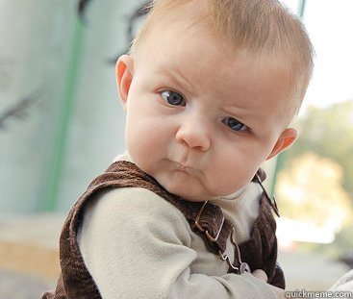
“The Look”

