S. C. I

World

Newsletter of the Joseph Groh Foundation
Fall 2017

News Bytes
Foundation hosts Chicago & Minneapolis Golf Tournaments

This year’s Chicago event held at historic Ominous clouds belie sunshine during lunch
Itasca Country Club

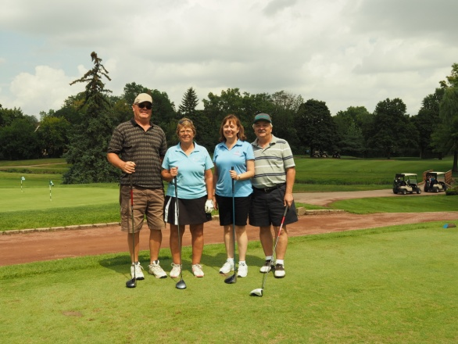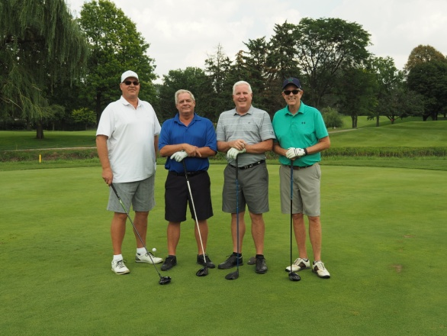
Sue’s former college roommates Denise Best Joe’s former workmates Jack Poehls (L) &
(L) W/husband Steve & Marge Johnson John Rohan (2nd from left) along W/Gary Doles
(R) with husband Jerry came to play & Mike Coughlin never miss our tournaments

On Monday August 28, 78 golfers met at the venerable Itasca Country Club in the western suburbs of Chicago to golf in the fourth annual benefit for the Joseph Groh foundation. The weather looked promising at the start of the day, even though forecasts called for some rain. Forecasts became a reality however as play was suspended following the 14th hole. It was the second year in a row play was shortened due to rain. Nevertheless, golfers enjoyed the event and look forward to next year’s tournament – perhaps during a different month! The foundation thanks all the sponsors, golfers, donors and volunteers for their contribution to individuals from our industry who are living with a life altering disability!

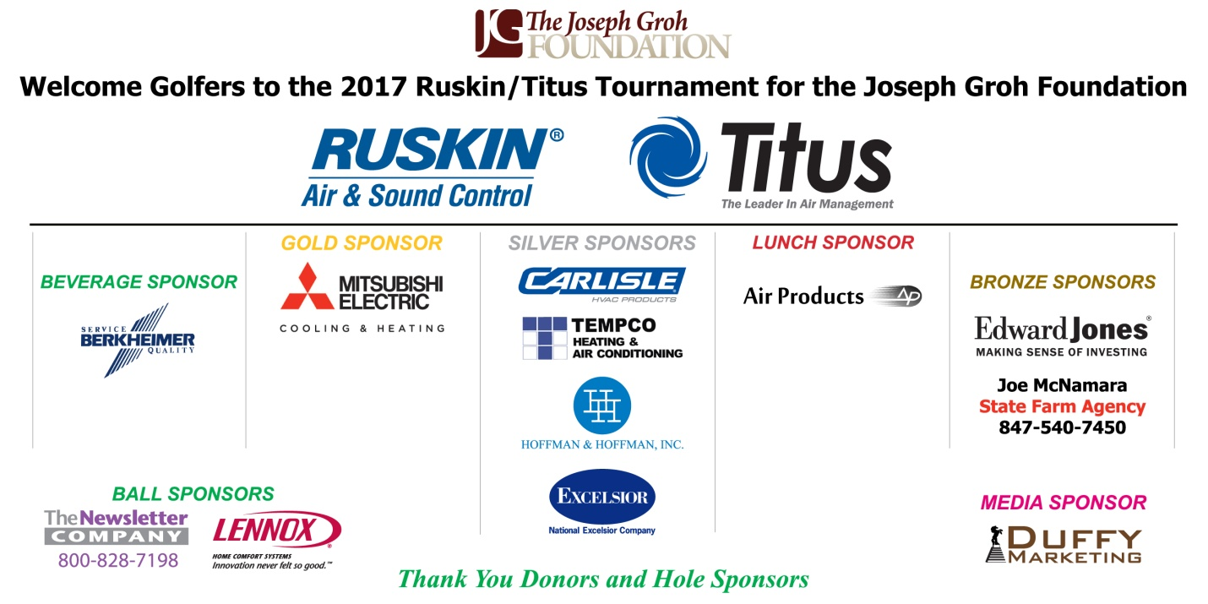

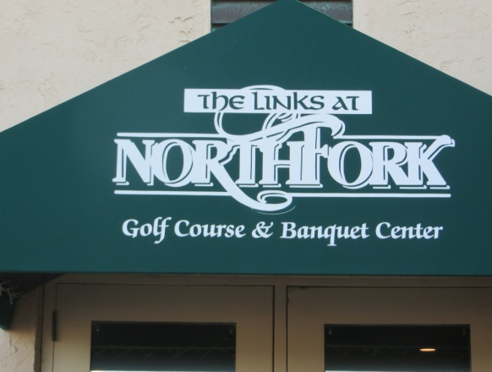
Minneapolis event held at Links once again Golfers tuneup their swings prior to start
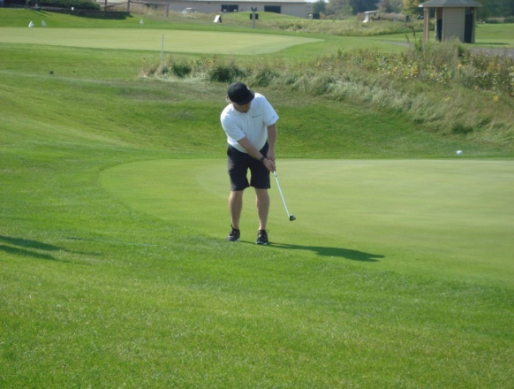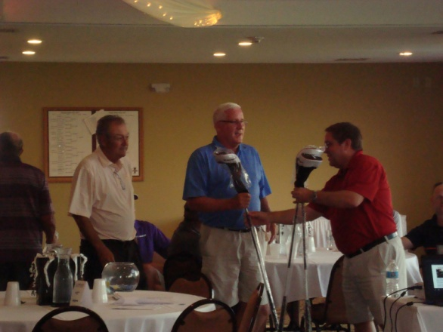
Long time foundation supporter Billy Prewitt Volunteer George Groh hands out prizes to
of Carlisle Hardcast chips onto green John Rohan and Larry Gullick

On Monday, September 11, 55 golfers met at The Links at North Fork for the second annual Daikin Tournament for the Joseph Groh Foundation. The weather couldn’t have been better for the golfers as they prepared to play at one of the few true Scottish links style golf courses in Minnesota. The Links features a 4-star Golf Digest rated championship golf course, and is one of the most popular venues in Minnesota. Daikin Applied was the title sponsor for the second year in a row. The foundation thinks all the sponsors, golfers, donors and volunteers for their contribution to individuals from our industry who are living with a life altering disability. We look forward to announcing plans for the 2018 tournament in the near future.

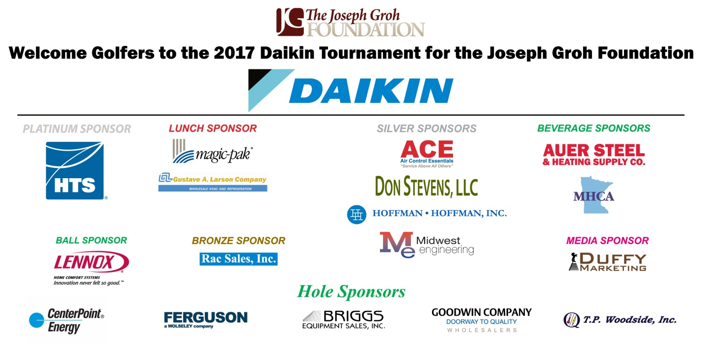

Breaking News!
Mark your calendars for the following two golf tournament benefits for the foundation in 2018. Chicago is TBA.

Dallas: Coyote Ridge Golf Course, Carrollton, Texas
Monday, May 7, 2018

Minneapolis: The Links at North Fork, Ramsey, Minnesota
Monday, September 10, 2018

Service World Expo Raises Funds for the Foundation

The second annual Service World Expo was held September 7-8 in Las Vegas, and over 1000 tradespeople attended the innovative convention. The multifaceted seminar is designed to provide superior business services to residential HVAC, plumbing and electrical contractors. “Over and over, the consistent feedback we heard from exhibitors was about the quality of the attendees,” said Liz Patrick, vice president of strategic alliances for the Service Roundtable. “There were not only more people here than last year, but engagement was off the charts,” said Jen Anesi, chief editor, Plumbing and Mechanical. Instead of wandering around or skipping out of sessions, which sometimes happens at trade shows, these attendees packed not just the keynote presentations but also the breakout sessions, which covered topics ranging from improving sales techniques to managing millennial employees, improving search engine optimization, diversifying one’s business, and so much more. But that wasn’t all.

Vendors such as Vicki Laplant, Comprehensive Employment Solutions, Rotobrush and more donated items for an auction at the Joseph Groh foundation booth. In all, attendees pledged $8000 to the foundation!

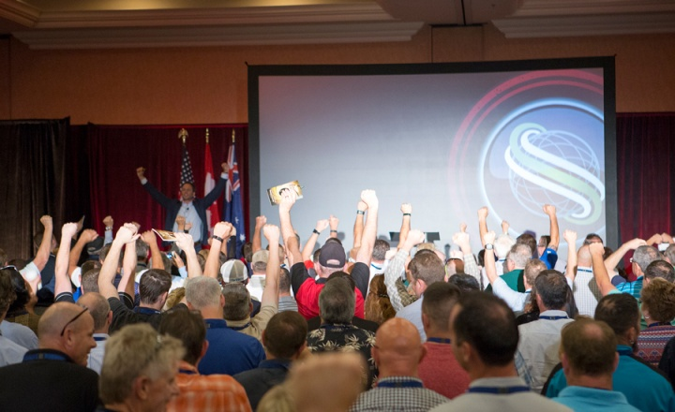
Service World Expo Attendees at Keynote Speech

Charlie Yerger – Latest Grant Recipient of the Foundation

Foundation Recipient

Charlie Yerger
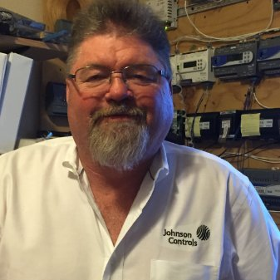
Charlie On the Job

Charlie’s Story

Charlie’s initial degree was not predictive of what turned out to be his passion. He turned a degree in EMS/Paramedicine into a career of working with HVAC control systems. Charlie’s HVAC career started as an installation foreman for a controls contractor, which led to working as a technician for a large residential and commercial HVAC contractor in central Texas. In 2006 Charlie joined Johnson Controls Inc. as a Systems Technician on a major projects team, doing service work in specialized building systems areas.

In 2013 Charlie was diagnosed with muscular dystrophy!

Several years later the diagnosis was narrowed to that of Bethlehem Myopathy, an inherited movement disorder characterized by progressive muscle weakness and joint contractures in the fingers, wrists, elbows and ankles. Doctors came to this diagnosis after several abdominal surgeries following a muscle biopsy. After the original diagnosis, Charlie was only able to work about 8 months over the next 3 years due to hospital stays and doctor appointments. Charlie is persistent however, and transitioned to working as a remote product support technician for Johnson Controls two years ago. This enabled him to work from home, providing technical support for the FX and Metasys product lines. The change however meant he was no longer able to work in the field, thereby losing a considerable amount of pay. Charlie’s condition now requires that he use a power wheelchair, which means he needed a truck lift for his wheelchair and an accessible bathroom. In early 2017, Charlie Yerger sent an application to our foundation for a wheelchair lift for his truck and a bathroom remodel. Charlie had learned about our foundation through foundation board member Eric Groh, who is also a JCI employee. Charlie is one of the individuals that Eric speaks with when he calls into technical support. From the pictures below, you can see his truck lift and why Charlie’s bathroom was in such need of a remodel.

Thanks to your support, the foundation was able to grant Charlie’s wishes.

Following completion of all the work, Charlie said, “I just don’t know how to thank all of you enough. I am still searching for a more adequate way to thank you and all your foundation has done to make my situation more comfortable and keep me active.”

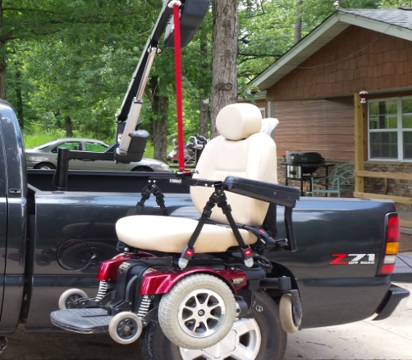
Lift Hoisting Wheelchair Into Bed

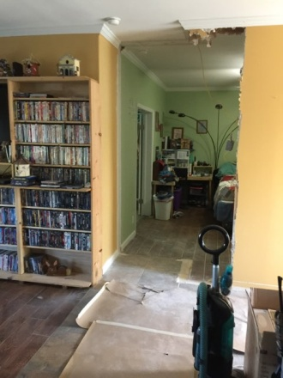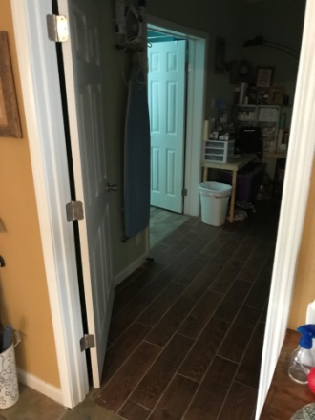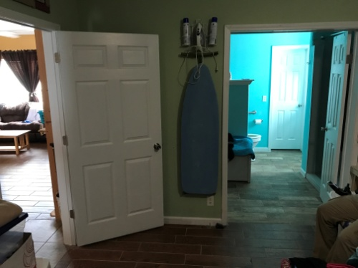
Widening bedroom entry Entry after widening Entry (L) seen from inside bedroom

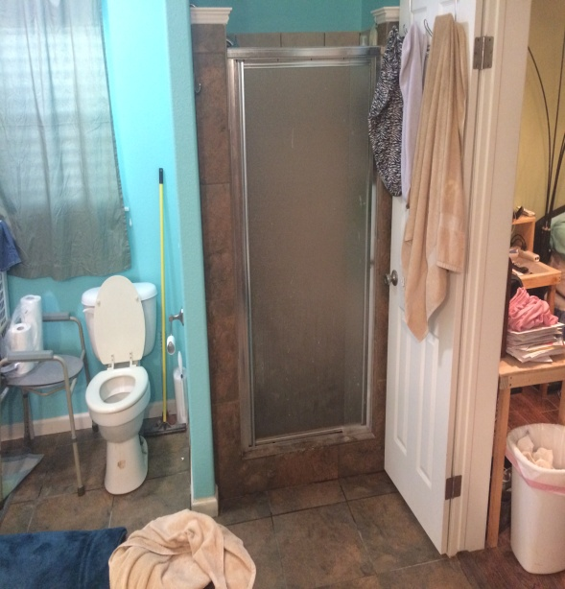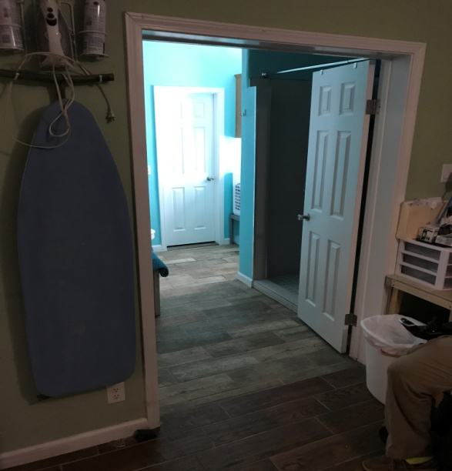
Bathroom before remodel New entry to bath from bedroom, roll in
shower is on the right

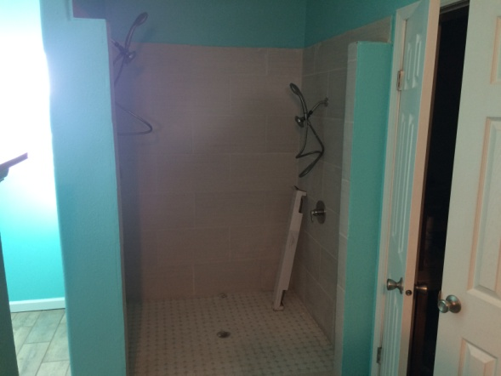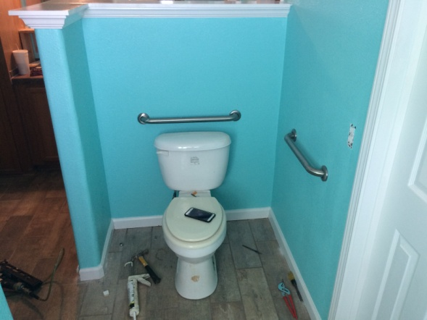
Roll in shower Relocated toilet ~where garden tub was

Exoskeleton Devices on the March!

According to the University of Alabama at Birmingham, Exoskeleton technologies are once again in the news. In February, suitX launched its Phoenix exoskeleton. It costs $40,000, but the company claims it is currently “the least expensive of all exoskeletons.” It weighs 27 pounds, making it also one of the lightest exoskeletons available. The battery life offers up to 4-hours of continuous walking time and a maximum walking speed of 1.1 MPH.

In March, the FDA approved the Indego exoskeleton for both clinical and personal at-home use. The Indego is priced at about $80,000. It weighs in at 26 pounds, which is also among the lightest exoskeletons. Indego’s battery life is also listed at about 4 hours of use, but the company brochure does not mention a maximum walking speed. In April, Ekso Bionics gained FDA approval for its Ekso GT exoskeleton. While other exoskeletons are approved for use with persons with paraplegia, the Exso GT is the first exoskeleton cleared for use with persons with injury levels from T3 to C7 (ASIA D ~incomplete spinal cord injury) in a rehab setting. It is not approved for home use. There are no details on weight, speed and cost on their website.

All have unique features, but the big question remains: who will pay for it? Although the ReWalk exoskeleton is now covered by the US Department of Veterans Affairs at a cost of around $70,000, there is no Medicare/Medicaid “rate code” for exoskeletons. Without a rate code, there is no health insurance payment and no reimbursement for up to 80% of the cost as a medical device. Getting that rate code might take years. Until then, the cost is out of pocket. It is obvious, though, exoskeleton technologies are quickly evolving. Units are getting lighter and more compact. Battery life is getting longer. Units are getting modular. Exoskeleton technologies may be on the path to one day replace manual wheelchairs.

Information courtesy of Pushin On, a digital newsletter of the UAB Rehabilitation Center.

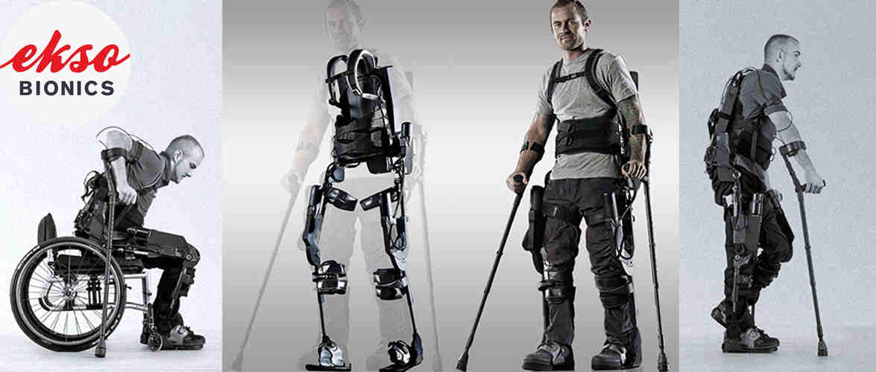
Picture of man equipped with exoskeleton technology

Nurses

Reprinted by permission from Handihelp Blog. In 1965, after graduating from a SUNY College, Rich Fabend began teaching social studies in a small rural school in upstate New York. Over the next 32 years he received certification as a high school principal, health teacher and teacher of special education. During a two-year hiatus from teaching in the public school system, he served as a Education Coordinator for the New York State Division for Youth. In February 1999, while on vacation in the Caribbean Rich was struck by a wave which drove him to the bottom, breaking four vertebrae in his neck and leaving him a C6 quadriplegic. After six months of hospitalization and extensive therapy at Craig Hospital in Denver, he was finally able to return home to begin his new life.

Can you possibly understand the role you play in your patients' lives? I received a Christmas card the other day (February 10) from a woman I haven't seen in probably 14 years. She played a critical role in my life 17 years ago when I was a rehabilitation patient at Craig Hospital. I was so scared when I got there. My stay at Craig was almost 5 months because of the stage four pressure wound on my sacrum. It was the result of being strapped to a backboard for over 36 hours. Most of the first 3 months were spent cleaning the wound to get it ready for skin flap surgery. Much of this time I was unable to speak because of the tracheotomy.
A young woman named Marsha was one of my nurses. She was beautiful, funny and had an infectious laugh. She provided my care in a manner that made me feel special and safe. We have kept in touch since I left and even saw each other once when I went back for a reevaluation. I often wonder if she has any idea the critical role she played in my recovery. She has since left Craig and has a family, but still lives in the Denver area.
Marsha worked days, but the most difficult time for me was during the night. I had become afraid of the dark and absolutely petrified to be alone. I had a boom box which my wife loaded with CDs before she left. Everything was manageable until the music shut off. In a matter of minutes I would have full-blown night terrors which turned me into a raving maniac. It got so bad that the nurses would wheel my bed out to the nurses station so they didn't have to continually come into my room to calm me down. There was another young nurse who worked nights. I have long since forgotten her name. I can still hear her soothing voice as she tried to calm my hysteria. Things were always a little bit better when she was on duty. When I returned to Craig for a reevaluation I was saddened to find out that she had left and joined a traveling nurses group. In a wonderful effort to calm my fears she and Marcia bought two packages of the luminous stars and pasted them on the ceiling over my bed. At night the stars would radiate light for a while and then gradually dim and turned dark. When I was getting ready to come home, she came and had her picture taken with me and told me in a soft voice that she had only been a nurse for about six weeks. I was amazed.
When my wife and I were told at Craig that my quadriplegia would require someone to come to my house daily to help with my needs, get me dressed and in a wheelchair I was dumbfounded. I had always been a very private individual and prided myself on my independence and self-reliance. The thought of a stranger coming into my house every day was more than I could fathom. Rhonda began working for us about a year after I came home. She's worked now for more than 16 years and has become a part of our family. Her job description has grown to much more than that of a nurse. She is always willing to take part in my little adventures and to step up when I need help. One good example of this is the day she drove into my neighbor’s field and hooked a total strap on my wheelchair, which had become mired in the mud, and pulled me out with her four-wheel-drive truck.
I wonder if nurses know the critical role they play in their patient's life. I am positive my rehabilitation would not have worked out as well as it did without Marcia and the other nurse from the night shift. Rhonda's always willing to help attitude, has enabled me to pursue activities I never would be able to do otherwise. I look at the role these women played in my life and wonder if they can truly grasp how critical their care and support really is.

Website Additions To Links Section

- Business Ideas for People with Disabilities ~under national resources
- United Access ~under transportation/handicapped van suppliers
- Freedom Motors USA ~under transportation/handicapped van suppliers
- Medical Benefits of Standing ~under durable medical equipment tab
- Legal Resources for Special Needs ~national resources
- Keeping Disabled Persons Safe during remodel ~under caregiver help
- Disaster Preparedness for Special Needs ~under caregiver help
- Disability and Credit Scores ~under national resources
- Disability Resources from Dept Of Labor ~under national resources
- Decluttering home for the disabled ~under caregiver help

The addition of these links means there are now 181 different sites linked to the foundation webpage, making it one of the most complete reference sites available anywhere! If you see a website you believe would be a good candidate for inclusion on our links section, just let us know.

Henry Evans – Someone You Should Know

Henry Evans was driving his kids to school in 2002 when he began slurring his words. He said he felt sick and everyone thought he was going to drive off the road. He didn’t, but by the time he got back home he was losing his equilibrium. In the next few hours, his life was turned upside down. He was taken to the hospital where he was diagnosed with a stroke like brainstem disorder. That left the father of four mute and quadriplegic!

The Stanford MBA and chief financial officer of a Silicon Valley software startup woke up in the ICU, unable to speak or move. His fully intact mind was trapped inside his body, and he was not able to breathe on his own. In order to communicate, his children would hold up a group of letters and read them out. Two blinks of his eye was for yes and one was for no. In this manner they would slowly spell out each word, letter by letter. It was a torturous process, and for about five years Henry wasn’t even sure life was still worth living.

Eventually Henry contacted Chad Jenkins, an old friend, with whom he shared an idea about how to computerize this process, allowing eye movements to be verbalized into words. His friend took on the project with a robotics team he was mentoring. After building a prototype, the team applied for and won a grant from MIT to build an advanced prototype and present it at MIT. The result was a head tracking device and laser pointer letter board that Henry uses to control anything electrical that he can point the laser at. After catching a CNN interview of a Georgia Tech professor showing research he had done with a Menlo Park based robotics firm, Henry recognized the opportunity to develop the research into a body surrogate. For the next two years he collaborated with the professor on ways to use robotics as body surrogates for the severely disabled. The results were nothing short of incredible! In October, 2013 Chad and Henry presented a TED talk to show how robotics, personalized by a group Henry named Robots for Humanity, will help severely disabled people live their life to the fullest. Please follow the link below to watch this amazing presentation!

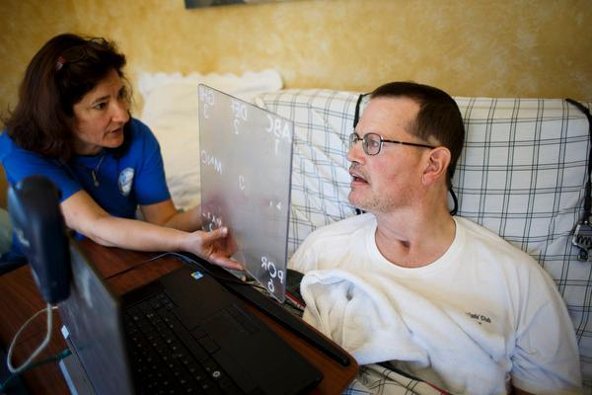
Henry Evans communicates with his wife Jane, using a letter board which verbalizes his eye movements.

https://www.ted.com/talks/henry_evans_and_chad_jenkins_meet_the_robots_for_humanity#t-598820

A Day in the Life

This feature is a sometimes humorous, sometimes offbeat, and sometimes irreverent look at life as seen through the eyes of a severely disabled person. Management takes no responsibility for these ramblings.

Medicine Is a Contact Sport

When I was growing up, basketball was called a non-contact sport. If you have watched an NBA game lately, particularly one where the stakes are high like The Finals, you’ll know this is certainly not the case today! Medicine is really no different. When I was growing up, doctors were put on a pedestal and their proclamations were not to be questioned, only followed. Rarely did I hear my parents or grandparents debate the wisdom of what they had been told by their doctors. As a child, I remember talking about various families we knew, and when we hit upon a certain name my parents would exclaim, “His dad’s a doctor.” There was unmistakable reverence in their comments, and it built the impression of infallibility in my mind.

I’m not sure when that changed, but I am sure it didn’t happen overnight. Perhaps it was Watergate, changing demographics in America or the reduction in middle-class jobs with comprehensive healthcare benefits, but something caused us to feel okay about questioning our doctors diagnosis and prescriptions. As I journeyed through the years of my adulthood, my increasing exposure to the medical world caused me to no longer put the medical field in general or doctors in particular on a pedestal. It was nothing that had reached the definition of a contact sport, it was simply an understanding that I had a stake in my doctors decision about any medical issue I brought before them. That all changed however on June 15, 2008.

Thz date I became paralyzed as the result of a bicycle accident became the date that medicine turned into a full contact sport for me. From that point on, I have had near constant exposure to the medical world. Many experiences since that date have tattooed on my brain the fact that you simply must be your own best advocate when dealing with medical issues. I think it started when I was in the hospital shortly after my accident. A technician drew blood during a routine procedure where where no blood should have been present. She called for the doctor de jour who stopped by, and after a thorough sixty-second evaluation, exclaimed “that could be a sign of cancer.” At first his words were concerning, but after the shock wore off I knew it was simply a case of the tech having botched the procedure. I had a more serious point of contact in the rehab hospital. While evaluating choices for rehab, we initially spoke with a young, attractive sales representative for a Dallas rehab facility. She told us we would likely be there for a couple of months, and during this time I would recuperate and learn to live with my new reality. After I was admitted to the rehab hospital and evaluated, we had our first meeting with the spinal cord injury staff. We will never forget the looks on their faces as we went in for our first Monday morning review session. Not one person was willing to look at us, and they all appeared as though they had just heard their dog had died. They started the meeting by telling us that we would be discharged in 3 weeks. Needless to say, we were in shock. We really didn’t know what to expect from rehab, but one thing was now for sure. We needed to expect a lot less.

Over the next few weeks I was a bit of a problem child, medically speaking. Every morning a nurse would come around to take my vitals and administer pills. When I arrived at the rehab hospital, I was on prescriptions for about about 8 different medications. After that came a visit by the doctor in charge of spinal cord rehabilitation. On a number of occasions, I was running anywhere from a temperature to a slight fever, for which I was mildly admonished. I think the fact I was running a temperature inhibited progress toward my release. I did not realize at the time that the source of this problem was likely a UTI, for which I was never tested. Five months later after a continuation of these issues, I ended up with sepsis, which is a life-threatening situation.

Since that time I have acquired a lot of “ists” (Neurologist, podiatrist, gastroenterologist, urologist, dermatologist, baclofen specialist, colorectal specialist, spinal cord specialist, wound care specialist, hematologist, criminologist ~okay maybe not the last one) along with other non-–ist doctors like my primary care physician. My job as I see it, is to avoid these people like the plague! If you linger around any of them too long , they introduce you to some of the “ists” in their life. These people are called surgeons, and if you hang around them too long you will end up in a place called the operating room. Trust me, they are very cold and are followed by several days of bad food. While the vast majority of doctors I have worked with since my injury have been professional and caring, I have learned to do my own research so I can either rebut their opinion or suggest alternative solutions if I feel it necessary. I always go to an appointment with a written list of questions, and I don’t let the doctor wriggle out of my grasp until we have discussed all of them. This has led me to confront symptoms sooner and be on fewer medications since the start of my injury. I believe this practice has kept me healthier over the years, and perhaps my doctors have learned some things about people with my condition as a result. I always enjoyed contact sports before my accident, and apparently I still do!

Secret Photo Taken at Doctors Office Following My Last Visit!

Image courtesy of Gomer blog.com

